KPgolem

**Overview**

Interface hardware and software to punch and read on IBM Keypunch machines, initially tested with model 029 but should work, at least punching, on model 026. It is an open source design, available on Github

There are three elements to the interface:

1. Modifications to the keypunch and wiring one or two cables that will connect to the interface box. The second cable is optional and supports reading and verifying of cards.
2. An interface box based on an Arduino microcontroller and relay boards that will sit inside the keypunch, hooked by cables to the keypunch mechanism, connected by a serial cable to the user via a terminal, programs, or the optional third element, PC based software.
3. A program that runs under Windows on a desktop, laptop or Surface Pro computer, communicating over a serial port to the keypunch interface program. This program allows text files on the PC to be punched onto cards by the keypunch, as well as the reading of existing cards through the keypunch into Windows text files.

The easiest way to use the system is to combine all three elements, providing a user-friendly modern graphical interface and straightforward process for punching decks from the computer. The first part of this documentation will cover the PC based program and its use.

The protocol for the serial link that connects to the keypunch interface box was designed to make it easy to use and to debug. All messages are in ASCII with a flexible simple set of command verbs and nouns. The responses are easy to interpret without any reference materials.

The keypunch can be completely controlled and used to its full potential through a simple terminal connection, without any programming. It is also amenable to connection and use from a variety of programs and systems.

The second part of the manual documents the protocol for the serial connection, for those who will control the interface without the included PC program. There are some additional capabilities of the keypunch interface which are not exploited by the PC based software.

**PC based software to drive the keypunch**

The KeyPunchInterface program is started by launching the executable file of the same name. It maintains a configuration file, creating it if necessary, to track the user’s selection of serial port and encoding to relief the user from having to reselect these on each invocation.

If the configuration file (KeyPunchInterface.ini) does not have a remembered serial port, the program will begin by showing a dialog box with a list of all the available serial ports on the Windows system. The user highlights the one that is connected to the keypunch and confirms with the “Okay” button to begin using that port.

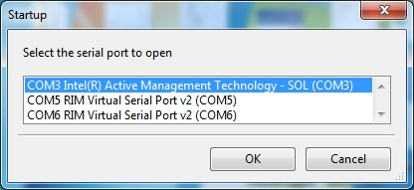

Once the port was selected, the choice is saved in the configuration file. Every subsequent start of the program will use the saved serial port and immediately connect to the keypunch, skipping the dialog box. There are two ways that the user can return to the dialog box to select a serial port – if the saved port is no longer available under Windows or if the user selects a menu option to forget the saved port. In those two cases, the configuration file entry is erased and the user is asked to close and restart the program to begin with the dialog box and choose a new serial port.

The program will try to connect to the keypunch interface, requesting a simple built in diagnostic (Diag 0) that verifies the connection of the punch and the reader cables from the keypunch mechanism to the interface box. The program has a ten second timer to catch the case where the interface box is not connected, not powered up, or there is another problem that blocks connectivity.

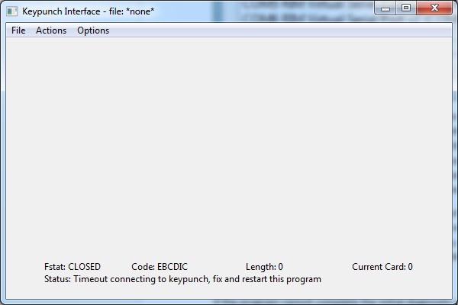

If the program cannot complete the initial diagnostic on the interface box, it informs the user of the error but will continue to run, although with reduced functionality. It makes no sense to attempt any function that needs the keypunch interface or mechanisms, so these menu choices are disabled (grayed out). The user can still open files and move around in them.

The main screen has a section across the bottom that displays key status information. It is divided into two lines across the bottom. The bottom line has a status message. Both successful actions and error conditions can post messages here. The upper of the two lines delivers the status of the program with four key metrics.

Fstat is the status of the file, either OPEN or CLOSED. Code informs the user of the encoding that is selected; this can be binary encoded in ASCII BCD encoded in ASCII, EBCDIC encoded in ASCII or others. All allow the user to create and manage simple ASCII text files to represent punch card images. These files have a suffix of .txt allowing them to be easily edited by Notepad, Word or other text editor program.

The title bar of the main window displays the filename of the currently opened file, or *None* when files have been closed. The remainder of the window will display the card images with automatic scroll bars depending on the size of the file.

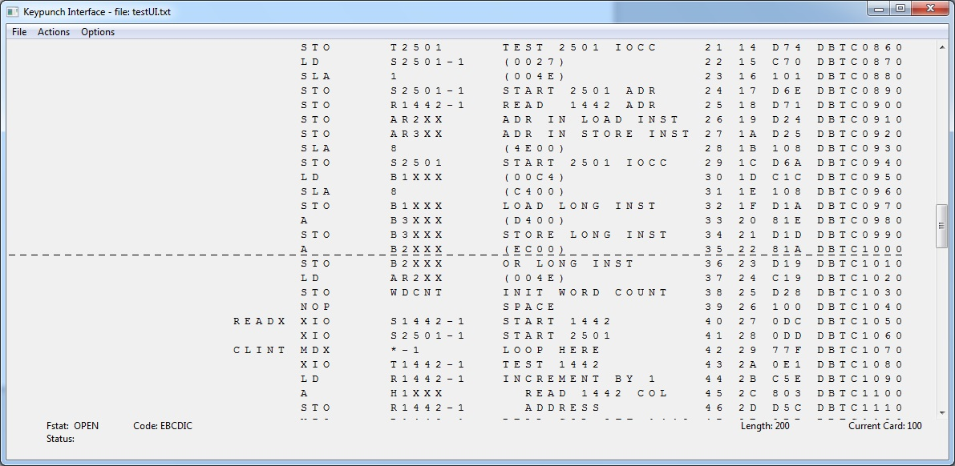

Here we can see a card deck containing 200 cards, encoded as EBCDIC in ASCII, with card number 100 as the currently active card. That means the keypunch will punch that card image onto a blank card and continue advancing through the file, sequentially from card 101 down to the last one. The window was resized to show all 80 card columns across – the right hand eight columns are card sequence numbers as was common with source program decks in the mainframe era.

There is a vertical scroll bar since all 200 card images are not visible in the window. If the window were resized with less horizontal space, such that not all 80 columns would be visible, then a horizontal scrollbar will appear.

Whenever the keypunch is paused, a menu choice will allow movement to a different card, which becomes the next one to be punched when punching is restarted. Files open up in paused mode, giving the user the opportunity to move away from card 1 to whatever card number they wish to begin punching.

The Go To item of the Action menu will put up a dialog box where the user enters the card number to which they wish to advance or rewind the current deck. The current card is marked with underlines, for ease of visual identification.

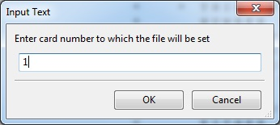

The current card number will jump back to card 1, with the card image highlighted by underlines as seen below. This is useful if a card is jammed or damaged, as the user can pause the punching, use Go To rewind to the damaged card and restart punching to get a new copy.

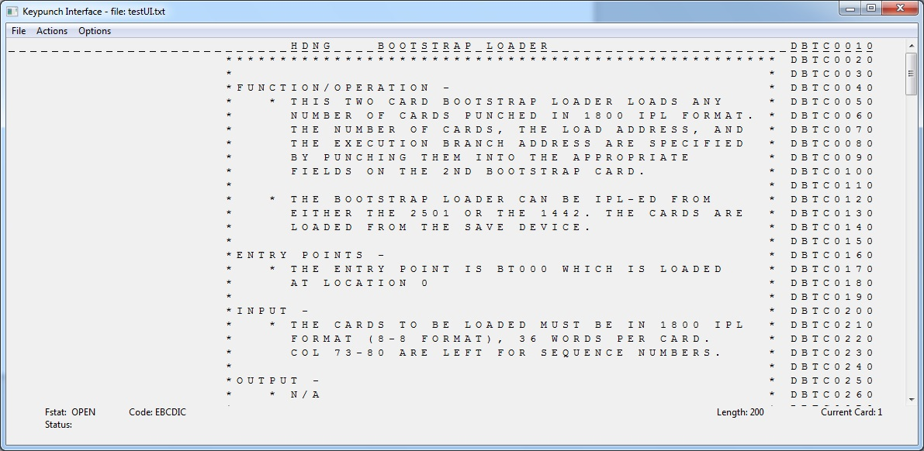

The program has three menus, File, Actions and Options, each of which offers a number of selectable items that control the program and keypunch. Almost every menu item has a shortcut, such as Control + Q to quit the program.

The Actions menu bar is how the user starts the keypunch punching the open file, pauses the keypunch, and changes the current card with Go To. In addition, if cards are being read on the keypunch to be stored in a newly created text file on the PC, the user would start reading instead of choosing start punch. In the screen shot, the entries are grayed out (disabled) because the program could not complete the Diagnostic 0 to verify a good connection to the keypunch interface box.

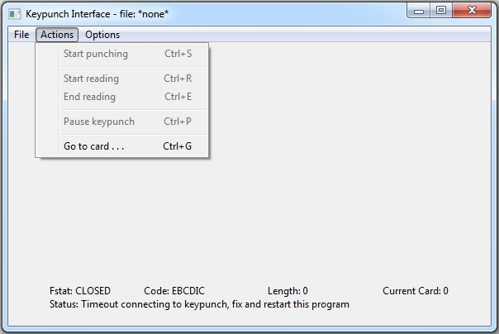

Ctrl-S starts the keypunch punching cards sequentially from the current card position, if a text file was opened with card images to punch out. If the keypunch is subsequently paused, it can be restarted by issuing Start Punching another time. This can only be issued if an existing file was opened.

Ctrl-R, Start Reading, is used when a new empty file is created to hold card images read in from a physical card deck. The keypunch will continue to read cards, appending them to the growing file being created on the PC, until the user declares the last card has been read by selecting the End Reading menu item.

Ctrl-E, End Reading, will stop the process of reading in cards. It, like Start Reading, can only be issued if a new file was created for reading.

Ctrl-P, Pause Keypunch, will stop sending card images to the keypunch if a file is being punched, or stop reading additional cards into a file if we are reading a deck.

Ctrl-G will launch the Go To dialog box where a card number is entered to become the current card.

The File menu is used to open existing PC files for punching on cards, create new empty file to read cards into, close an open file, and quit the program.

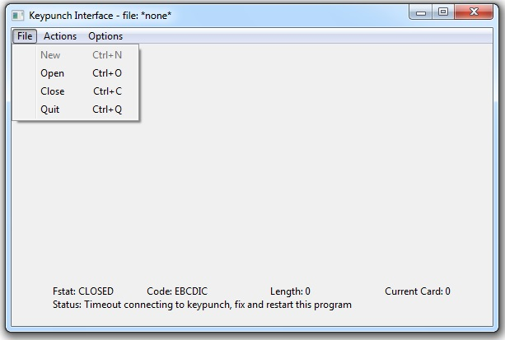

Ctrl-N creates a file that will be filled card image by card image as the keypunch reads in a card deck. It is an error if the filename already exists. This option is disabled if the program can’t connect to the keypunch interface box or if the keypunch does not have the read cable connected to the interface.

Ctrl-O opens an existing text file, displaying the card images in preparation for punching via the keypunch. The program validates the card images, ensuring that no line has more than 80 columns of data and that there are no characters in the file that are not in the encoding. See the appendix for the character encoding – the ASCII characters and the card patterns and native characters they represent. For binary mode, the file much consist of groups of four hex digits, each group separated by a space.

Ctrl-C closes any open file, while Ctrl-Q will shut down the program.

The Options menu is used to select one of the encodings for the text files, forget the saved serial port from the configuration file, display some information about the program, and to display the initially hidden log window.

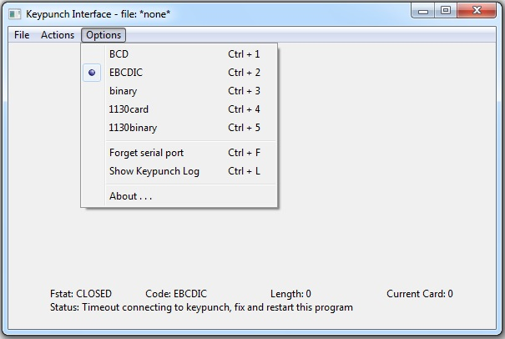

Currently, the program only implements the first three encodings, BCD, EBCDIC, and binary. The program will issue the appropriate commands to the keypunch interface to switch it into the same mode and will verify that it did so successfully.

Ctrl-1 through Ctrl-5 select the five encodings. The appendix details the encodings.

Ctrl-F will remove the serial port entry from the configuration file, after which the program must be restarted to go through the serial port selection dialog.

Ctrl-L, Show Keypunch Log, will make visible a Log window that is saving various status and error messages generated by the program. In addition, every line sent by the keypunch interface back to the program is recorded in the log.

Finally, the About entry will pop up a dialog with a short identification of the program.

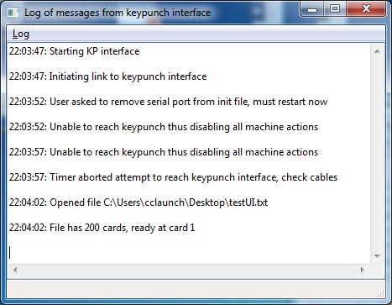

The log window can be closed, but remains active collecting messages which will still be there when it is made visible again by Ctrl-L

This window has a Log menu that offers a few choices – saving a copy of the log, clearing the current entries, and making it hidden again.

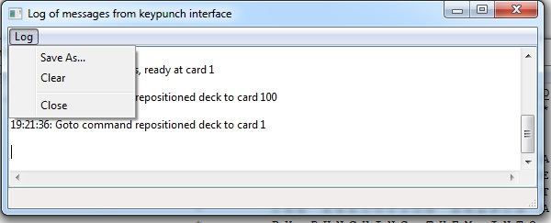

**Keypunch Interface box protocol over serial link**

To be completed

Version 0.3